**Communications Management Plan**

**Communication Management Plan**

**Breghhan Point of Sale System**

**Mt Makiling St**

**Makati City,1201**

**May 18,2023**

**Table of Contents**

Introduction 3

Communications Management Approach 3

Communications Management Constraints 3

Stakeholder Communication Requirements 4

Roles 4

Project Team Directory 5

Communication Methods and Technologies 6

Communications Matrix **Error! Bookmark not defined.**

Communication Flowchart 7

Guidelines for Meetings 8

Communication Standards 9

Communication Escalation Process 9

Glossary of Communication Terminology 10

# Introduction

The communication management plan will provide a structured approach for managing ang controlling project communications. Furthermore, it will help guarantee that all the information delivered to the stakeholders are true, accurate, and correct by using the most effective communication channels. With this, the team can mitigate risks, engage more with the stakeholder, and improve coordination.

This document also supports the processes for communication which can help minimize misunderstandings and facilitate project success. Furthermore, it defines the communication methods, key messages, and certain expectations on how the communication will flow. With this document, the team can identify which type of communication best suits a specific scenario for an effective communication within the project and ensure that every information conveyed to the stakeholders is true and correct.

# Communications Management Approach

The Communications Management Approach will be handled by the project manager and will ensure effective communication in the project. Furthermore, the project manager will ensure foreseeing the project and reporting the performance of each team member. He will also be responsible for seeing with the project stakeholders and is responsible for organizing meetings, meetings with the team members, and implementing a project plan.

The main communication zone for the team would be the creation of a team in Microsoft Teams in which all the documentation, minutes of the meeting, and status reports would be placed. Moreover, implementing this would ensure that all the team members would collaborate with each other in terms of accomplishing their tasks and at the same time adhere to the deadlines. With this, the project manager can convey all the necessary information to ensure stakeholder satisfaction.

# Communications Management Constraints

Effective project-related communications will be made possible by the project manager. The project manager will be held responsible for monitoring the project and reporting on its progress to the project team members and stakeholders. With this, there are some constraints that might hinder the project's progress, and it is important to identify these for the project manager and the team to produce risk mitigation. Some of the constraints that could limit the communication process among the stakeholders are within these factors:

* **Stakeholder availability**: With busy schedules and conflicting priorities, project stakeholders might find it difficult to attend meetings which can hinder the team in obtaining feedback which might lead to delayed communication.
* **Time constraints**: This factor might affect the communication process of the team and the project due to the strict adherence to the deadlines, it can limit the communication activities which can result in a limited opportunity. These things are spending more time on meetings for in-depth discussions which can have an impact resulting in more comprehensive communication.
* **Technical issues**: This would affect the communication process as there would be times when online meetings are necessary. Some of the factors that affect this would be the internet connection, the condition of the device, and the technological experience.

# Stakeholder Communication Requirements

The stakeholder communication requirements emphasize identifying the guidelines needed for effective communication throughout the project. Moreover, this part of the document will show all the requirements needed to build trust, credibility, and satisfaction among stakeholders. These are the things that are necessary to be standardized to attain a better relationship with the stakeholders:

* **Ensure information accuracy and relevance:** the project team should understand and identify the specific needs of each stakeholder and it should be tailored within their interests, responsibilities, and roles. Furthermore, only the relevant information should be conveyed to each stakeholder to ensure confidentiality.
* **Identify the communication channels:** identify the most effective communication channels for the stakeholders. This would ensure the project team had a better engagement with the stakeholders.
* **Give rapid regular updates:** this would ensure that all the possible risks that might arise are conveyed to the stakeholders as soon as possible. Furthermore, this would also guarantee that all necessary or relevant information is conveyed to the stakeholders promptly.

# Roles

**Project Sponsor**

The project sponsor is one of the key stakeholders which provides support for the project. They are also responsible for reviewing any changes to the project. Furthermore, they provide finances and processes necessary for the direction of the project. Lastly, their involvement and support are vital for the project’s successful completion.

**Project Manager**

The project manager is the one that plans, executes, and oversees the successful completion of the project. He/she is also responsible for maintaining the schedule, scope, budget, and the resources. In addition, their role is vital to the project team coordination as they will convey all the necessary requirements and critical decisions that would lead to a successful project. Lastly, their role is vital in communication with project stakeholders as they will be the ones that will convey all the changes and updates.

The project manager is also responsible for all the documentation needed for the project. He/she is the one that gives updates that might occur in the project development. Furthermore, their role is to ensure that all the documentation in the project lifecycle is up to date, accurate, and accessible.

**Development Team**

The development team are the ones responsible for implementing the technical aspects of the project. They are the ones responsible for developing, testing, and designing the project. Furthermore, their role is to ensure that the project’s vision will turn into reality. Lastly, their task is to achieve the project’s objectives.

# Project Team Directory

The following table presents contact information for all persons identified in this communications management plan. The email addresses and phone numbers in this table will be used to communicate with these people.

|  |  |  |  |  |
| --- | --- | --- | --- | --- |
| **Role** | **Name** | **Title** | **Type of stakeholder** | **Email** |
| **Project Sponsor** | Ms. Devilyn Ligligen | Bregghan Mini Grocery store owner | Internal | [bligligen@gmail.com](mailto:bligligen@gmail.com) |
| **Project Manager** | Ramon Benedict Elloso | Project Manager | Internal | [ramonbenedict@gmail.com](mailto:ramonbenedict@gmail.com) |
| **Development Team** | Donne Paolo Tarinay | Front – end developer | Internal | [donnetrainay@gmail.com](mailto:donnetrainay@gmail.com) |
| **Development Team** | Carlos Ligligen | Back-end developer | Internal | [ccligligen@gmail.com](mailto:ccligligen@gmail.com) |
| **Development Team** | Andrei Gabriel Palma | Quality Assurance Tester | Internal | [gabriel.palmaandrei@gmail.com](mailto:gabriel.palmaandrei@gmail.com) |

# Communication Methods and Technologies

For effective communication with the stakeholders, the project team needs consistent communication, especially when it comes to meetings. With this, misunderstandings would be prevented, and better relationships or rapport will be established between the stakeholders and the project team. In addition, constant updates and the project team being open with each other, including the stakeholders, will result in a decent work environment which can result in giving the best quality output. With this relationship, the project team members can give timely updates and offer the stakeholders a better understanding of project development.

Having the necessary utilities such as project management software and Microsoft Teams will help the project team in conveying all the necessary information to the stakeholders for them to be updated and satisfied.

Some of the factors determined to have the best communication methods are:

* **Budget Aligned:** the method of communication should be adjacent to the allocated budget.
* **Preference of Stakeholders:** To attain the best communication, it is important to adjust with the chosen stakeholders on whatever communication channels are available (face to face, or online)**.** Both can work, and the team can schedule a meeting by then.
* **Conveying Information:** depending on the stakeholders, the team can utilize both sending an email and links of documents. The document's links would include the weekly reports or updates, issues that might arise, and all requirements needed to assure stakeholders.

# Communications Matrix

|  |  |  |  |  |
| --- | --- | --- | --- | --- |
| **Communication** | **Purpose** | **Delivery media** | **Frequency** | **Audience** |
| Project Planning | Maintain the progress of the project team | Teams Meeting | Once before | Project Team, Project Manager, Project Sponsor |
| Sprint Planning | Have a monthly goal | Teams Meeting | Once before and after the development of a feature | Project Team, Project Manager, Project Sponsor |
| Release Planning | Handle all the dependencies | Teams Meeting | Once every month | Project Team, Project Manager, Project Sponsor |
| Product Backlog | Notify all the stakeholders about the unfinished processes | Teams Meeting | If necessary, only | Project Team, Project Manager, Project Sponsor |
| Project Consultation | Maintain project coordination | Teams Meeting | Once every week | Project Team, Project Manager, Project Sponsor |
| Project Updates | Progress or updates about the project | Teams Meeting | Once every week | Project Team, Project Manager, Project Sponsor |

# Communication Flowchart

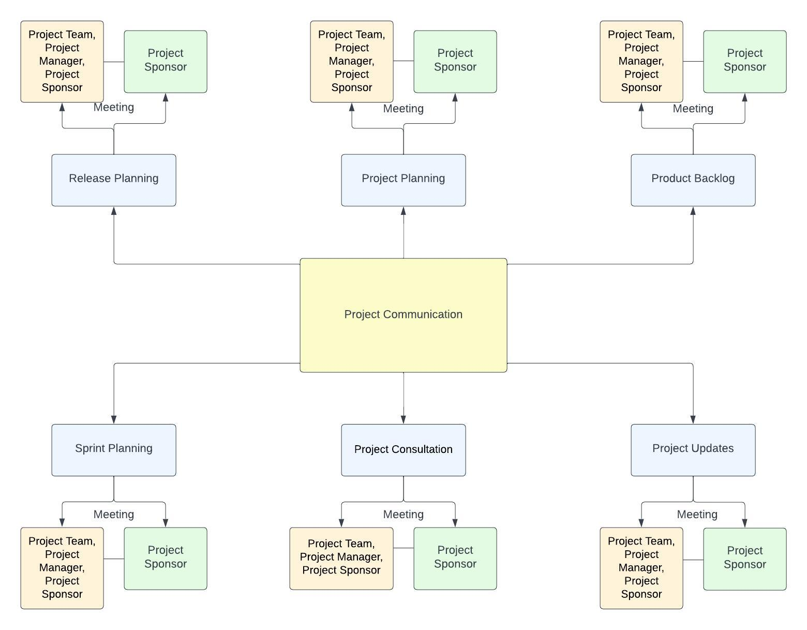

# Guidelines for Meetings

The guidelines for meetings part of the document make sures that all the meetings held in the project lifecycle are well-organized and contribute to the success of the project. Furthermore, the guidelines will serve as an outline on how the project team should run a meeting with or without the project stakeholders. With this, the project team can enhance their communication and collaboration with one another which can help create a positive impact in the project development.

The following steps will aid the project team members with regards to scheduling a successful meeting:

1. **Define the purpose and objectives:** the meeting should have a clearly defined purpose and objective correlated to the project.
2. **Make an agenda:** making an agenda with the outlines of the topics should be present and it is important to prioritize the agenda items based on their relevance to the project’s objectives.
3. **Identify the attendees and the roles:** it is important to identify the necessary participants regarding their roles and responsibilities. Furthermore, it is important to include the key stakeholders that impact the topic being discussed.
4. **Meeting Facilitation:** managing the time effectively is important in a project team meeting as it will allow efficient progress through the topics or agendas. Furthermore, it is important to start the meeting on time to minimize delays.
5. **Encourage active participation and engagement:** it is encouraged for all the project team members to speak up with relevance to the topic. This will promote open communication and active listening.
6. **Meeting Minutes:** creating minutes for the meeting will help the project team in identifying the resources that need attention. This will also serve as an attendance and progress report on where the project team is on the project. Furthermore, sending the minutes to participants after the meeting is necessary as it will serve as their reminder aid about the future topics and topics discussed.
7. **Meeting Evaluation:** Meeting effectiveness should be evaluated to improve project communication by participant feedback. In addition, giving meeting updates based on past meetings is also important as it raises the possibility if a project team member successfully finished his/her assigned task.

# Communication Standards

* **Clear and concise communication:** terminologies must be clear and easily understood by stakeholders. Furthermore, communication should focus on the relevant information and is based on objectives.
* **Active listening:** it is important for the project team members to attain active listening as it encourages a great environment for the meeting, and it encourages honesty and openness.
* **Proper Engagement:** it is important to seek input and feedback from the relevant stakeholders as it may help emphasize any suggestions for improvement. Proper engagement can also promote collaboration as it requires each member to ask relevant questions and seek clarifications. Lastly, it is important to avoid unnecessary questions that may lead to uncertainty.
* **Summarize from discussions:** this can attain improvement on any topic that needs clarifications from discussions, and it can help each team member retain focus on every meeting as everyone is on the same page.
* **Communication channels:** identifying the best communication channel can help the team in conveying necessary resources with each other and the stakeholders. Moreover, it is important that each team member should know the appropriate communication channel (email, online meeting platforms, or project management tools).
* **Schedule regular team meetings:** the project team should schedule team meetings every week to discuss any updates, issues, or progress. This will also ensure that everyone is complying with the project schedule and that all assigned tasks are completed promptly.

# Communication Escalation Process

The communication escalation process ensures that the communication issues are identified and resolved effectively, resulting in better project communication among the project team members and stakeholders. The escalation process should be adaptable along with the project lifecycle as it can ensure that all communication issues can be resolved quickly.

The communication escalation process for the Bregghan Point of Sale System is listed below:

1. **Communicate directly to the project team members:** With this, risks and issues can be resolved promptly. In addition, other topics such as discussions and updates should be directly communicated as a part of a routine.
2. **Manager involvement:** Escalate the issue to the team's designated project manager if any communication issues persist. It is necessary for the team to escalate the communication problem to the project manager if they cannot resolve it. The project manager's role is to help the team produce the best decision and try to resolve the issue.
3. **Involvement of the Project Stakeholder:** Whenever there are issues related to the end users and is not resolvable in the team level, it is important to escalate it to the project stakeholder and with this, necessary steps such as scheduling a meeting or sending a report stating how the team tried to resolve it should be taken into consideration.
4. **Written report about the issue:** After resolving any communication problem, a written report will be issued to prevent any future communication problems. Furthermore, this can help the team analyze and improve on the communication issues that arise.

# Glossary of Communication Terminology

|  |  |
| --- | --- |
| **Terms** | **Definition** |
| Information Accuracy | All the information given is true and up to date. |
| Active Listening | Giving your full attention, focus, and understanding to a speaker. |
| Communication channels | These are various methods or mediums to which certain information is conveyed. |
| Team Meetings | Team Meetings refer to the scheduled meetings scheduled by the project manager to get updates and reports from one another. |
| Meeting Minutes | A type of document that includes the timeline, attendance, and topics/agendas discussed in a scheduled meeting. |
| Meeting Evaluation | Meeting evaluation refers to the feedback gained from a team member after every meeting. |
| Project Manager | An assigned person that plans, executes, and oversees the successful completion of the project. |
| Meeting Facilitation | The process of identifying if the meeting duration is consumed effectively and efficiently. |
| Budget Aligned | A term referring to a certain topic that is strictly adhered to the budget allocated. |
| Proper Engagement | This term refers to the respective actions of each team member on the scheduled meeting. |

Sponsor Acceptance

Approved by the Project Sponsor:

Date:

Ms. Devilyn Ligligen

Bregghan Mini Grocery Store Owner